My dear brothers and sisters, October, 2022
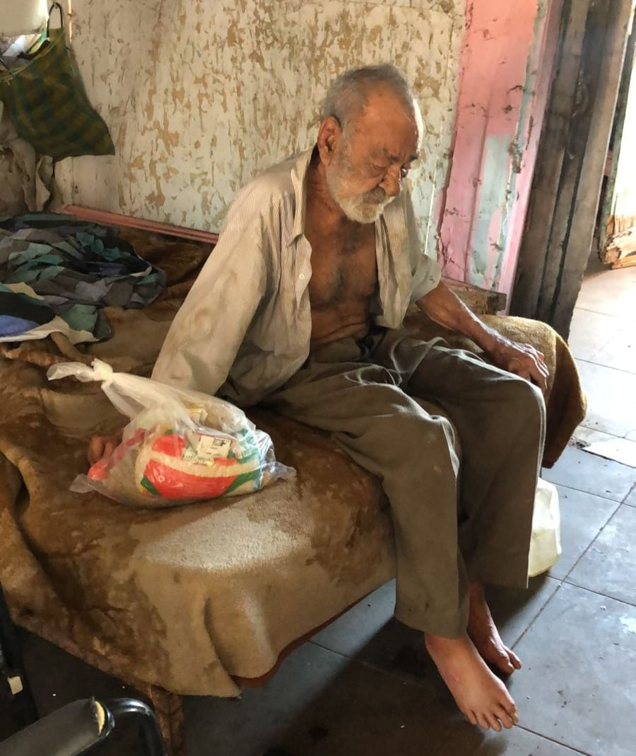
Walk with me down the dusty road to the shack of Rogelio. He is one of the many elderly that we visit, carrying a hot meal, food boxes, medicines, hygiene products, mobility devices, bedding and spiritual care. He was amazed and cried when our team brought out a bucket and mop and cleaned his humble home!

One of Rogelio’s fears was that he would die alone. Now he knows that he will have regular visits and we are praying for him. He feels God back in his life. He feels relief and hope.

Each month we deliver 1,000 food boxes to our brothers and sisters with stories like the one of Rogelio. As the Transitus (passing from this life to the next, October 3) of St. Francis approaches, I reflect on his death. He was surrounded by his brothers and knights from Assisi while music played. We may not be able to offer these features to our sick and dying but with your help we can provide comfort and dignity. What better way to honor the Transitus of our loving Francis.

I am reaching out to you to help us to help the forgotten ones. They deserve some respite from their daily burdens that we cannot even imagine. You can help to provide it. I am asking you for twenty-five dollars ($25) to allow us to continue. Donations can be made online:
www.casafranciscanaoutreach.org
or
send to PO Box 15576, Scottsdale, AZ 85267

Let us show these abandoned that God has not forgotten them. Surely, God will remember what you did for His children in His name at the time of your transitus.

With the love of St. Francis and peace and all good,
Fr. Martin Ibarra, OFM

